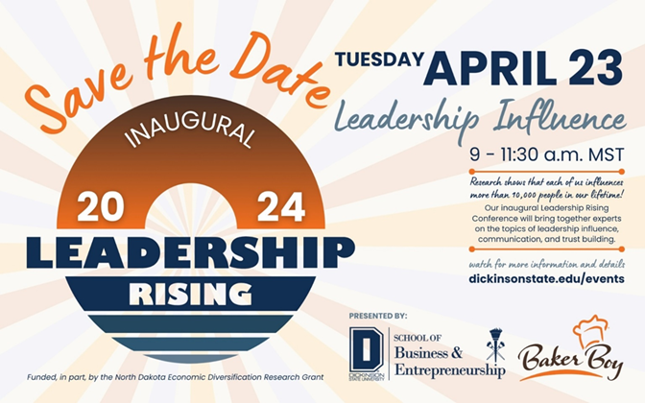

Subject: Request for Approval to Attend the "Leadership Rising 2024: Leadership Influence" Conference

Dear [Employer's Name],

I am writing to request your approval for me to attend the first annual "Leadership Rising 2024: Leadership Influence" conference, hosted by the School of Business and Entrepreneurship and Baker Boy at Dickinson State University. This conference, scheduled for April 23, 2024, aligns perfectly with our company's goals for leadership development and economic diversification.

The "Leadership Rising 2024" conference is an initiative designed to cultivate leadership skills among students and community business leaders.

Key aspects of the conference that align with our company’s objectives include:

**Leadership Influence**: The core theme of the conference, focusing on the impact of leadership in organizational growth and development.

By participating in this conference, I will have the opportunity to gain valuable insights and skills that can be directly applied to my work. It will also provide a platform to network with other professionals and leaders, fostering relationships that could benefit our company in the long term.

The conference is co-branded with Baker Boy and is part of a larger initiative to establish an annual educational event that serves as a catalyst for positive change and development in our region. As an attendee, I will also receive a certificate issued by the Dickinson State University School of Business and Entrepreneurship, further enhancing my professional credentials.

There is no cost for attending this conference. The investment of my time away from work will, I believe, yield significant returns in terms of the knowledge and skills I will acquire, which will directly contribute to our team and company’s growth.

Thank you for considering my request to attend this important and relevant conference.

I look forward to your positive response and am happy to discuss this further if you have any questions or need additional information.

Sincerely,

[Your Name]