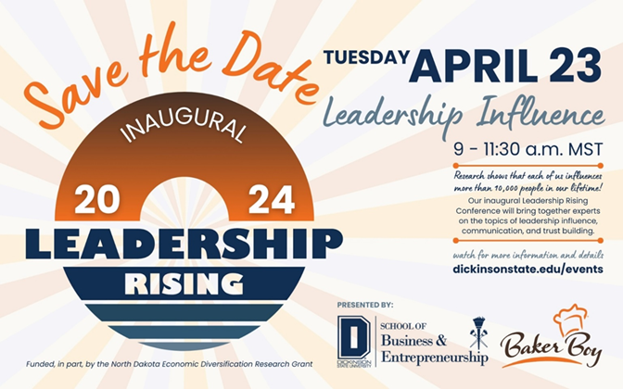

[Administrator's Name] [Administrator's Position] [High School Name] [School Address] [City, State, Zip Code]

Subject: Request for High School Student Participation in the "Leadership Rising 2024: Leadership Influence" Conference

Dear [Administrator's Name],

I hope this letter finds you well. I am writing to propose an enriching educational opportunity for the students of [High School Name]. We would like to invite them to participate in the first annual "Leadership Rising 2024: Leadership Influence" conference, organized by the School of Business and Entrepreneurship at Dickinson State University, scheduled for Tuesday, April 23, 2024.

This conference is an innovative platform designed to cultivate leadership skills. Hosted by the School of Business and Entrepreneurship, the event is aimed at fostering leadership development among students and community business leaders.

The conference will cover several key themes that would greatly benefit your students:

Leadership Influence, the topic of this year’s conference will focus on the impact of leadership in economic and organizational growth and development.

The event promises to be an eye-opening experience, offering your students the chance to engage with experienced leaders and peers from various backgrounds. It's a chance to network, learn, and gain insights that go beyond the traditional classroom setting.

The conference is co-branded with Baker Boy and is part of a larger initiative to establish an annual educational event that serves as a catalyst for positive change and development in our region.

We are committed to making this event accessible and enriching for your students. We believe their attendance will not only benefit them individually but also add great value to the learning environment at [High School Name].

Thank you for considering this proposal. We are excited about the possibility of having students from [High School Name] join us for this transformative experience. I am available to discuss this further and provide any additional information you may require.

Sincerely,

[Your Name]